**→ In this tutorial we will see that some times in image processing there are no need to use deep learning stuff we just using some other easy methods like traditional machine learning so our efficiency and speed both are increase for doing our day to day image processing :**

**(1) Image colorization using pillow library :**

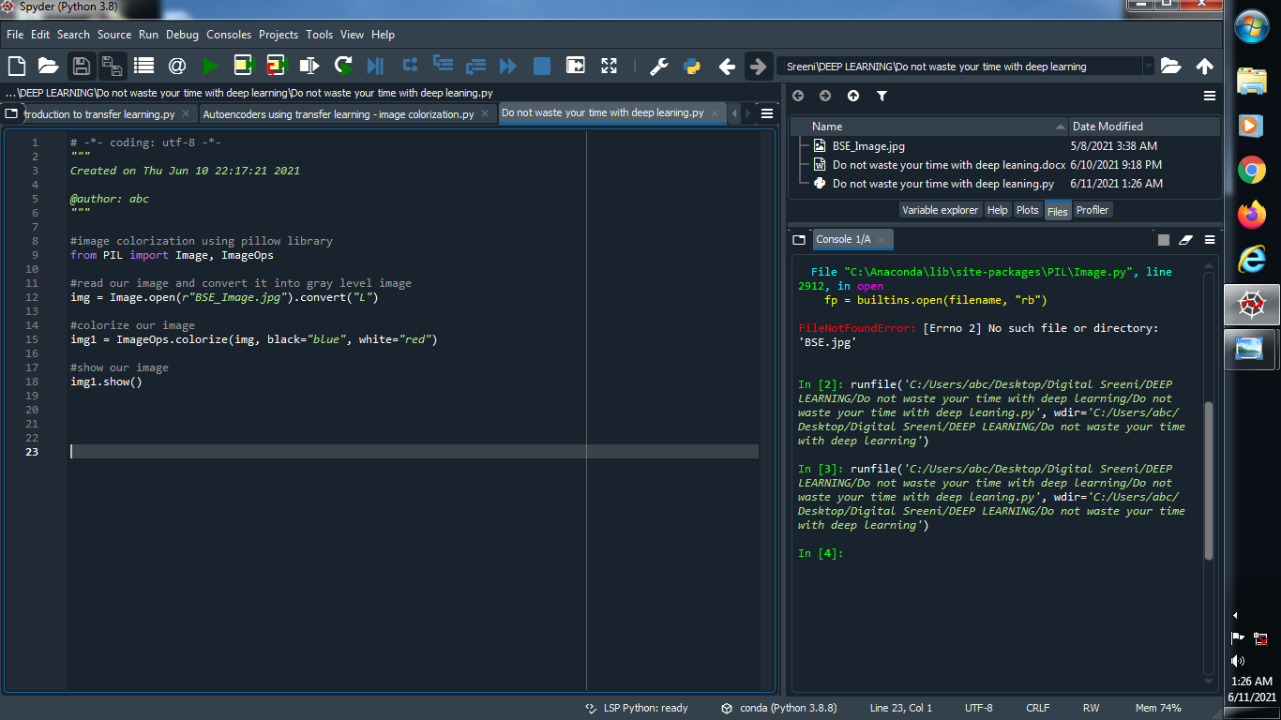

**Output :**

**Original image : Colorize image :**

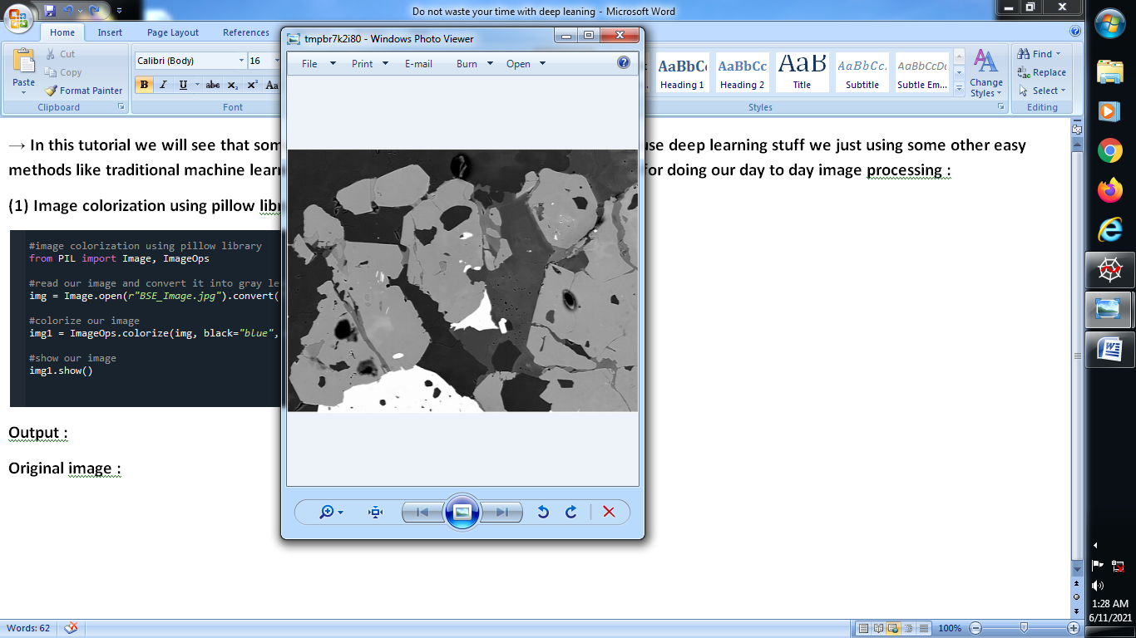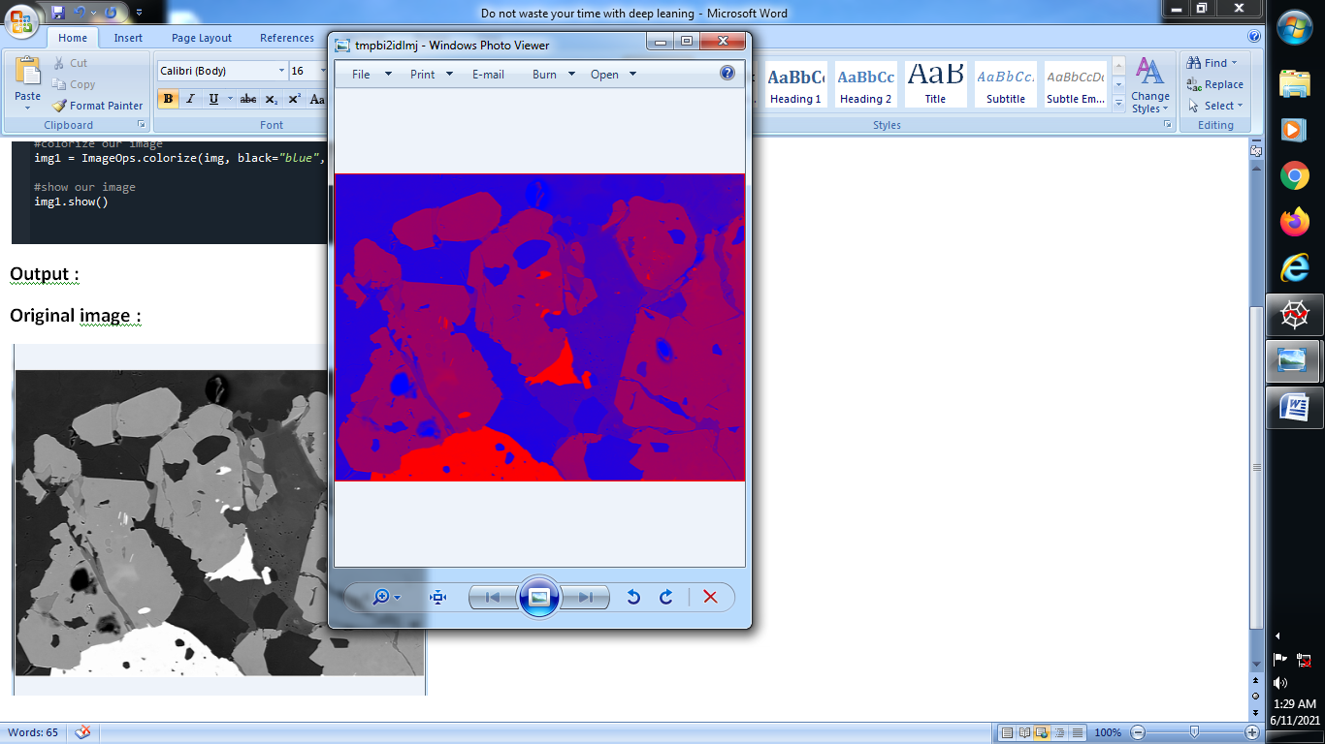

**(2) Image colorization using opencv :**

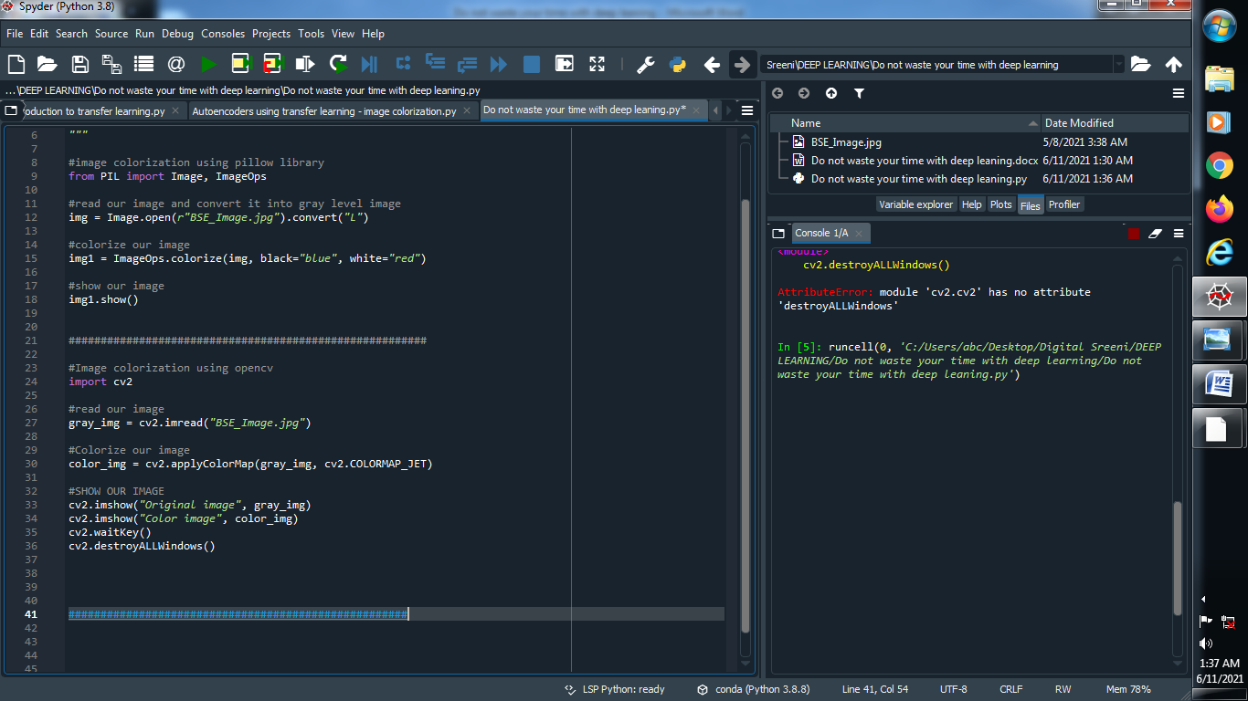

**Output :**

**Original image : Colorize image :**

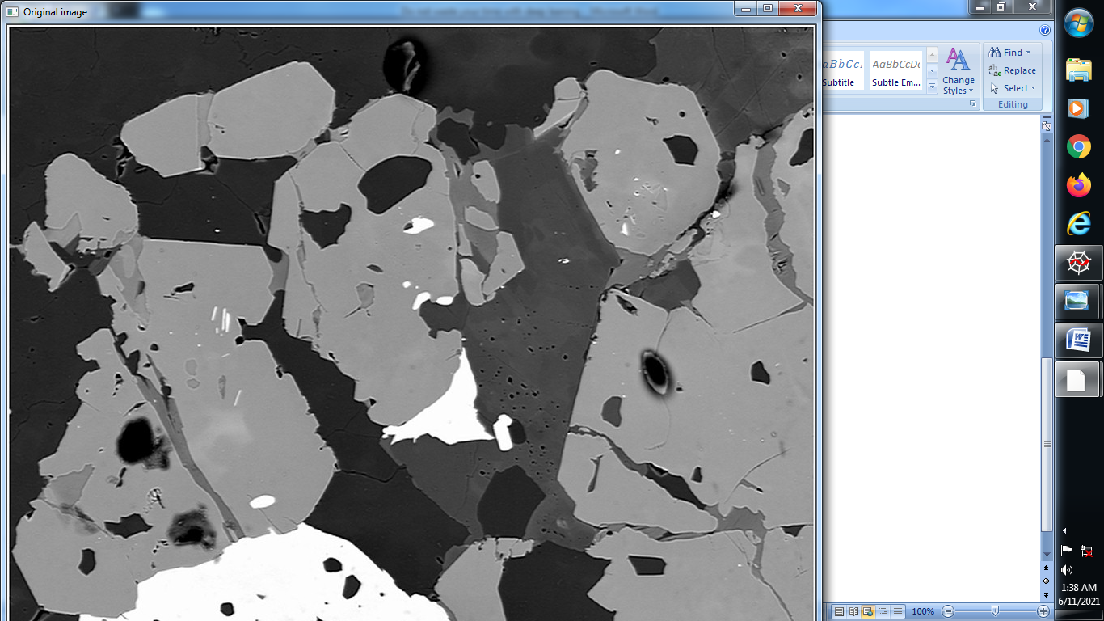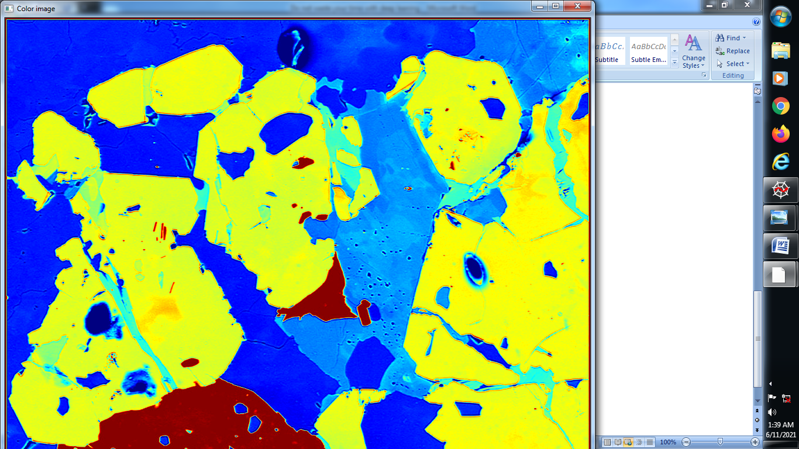

**(3) Denoise our image using Gaussian filter :**

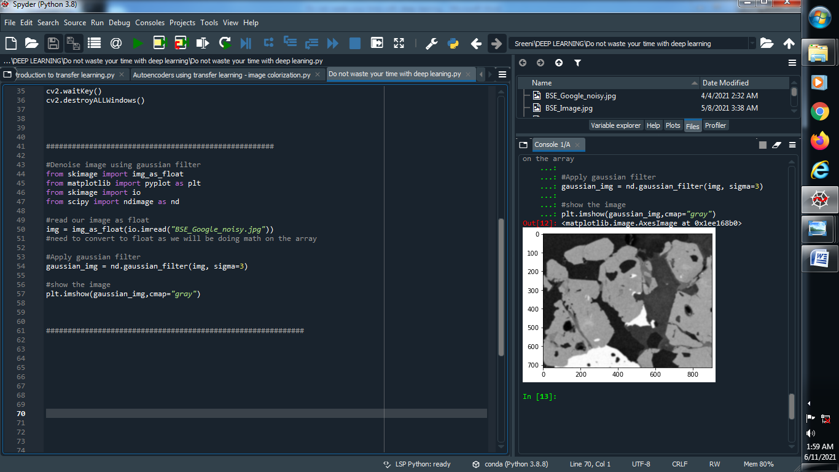

**Output :**

**Original image :**

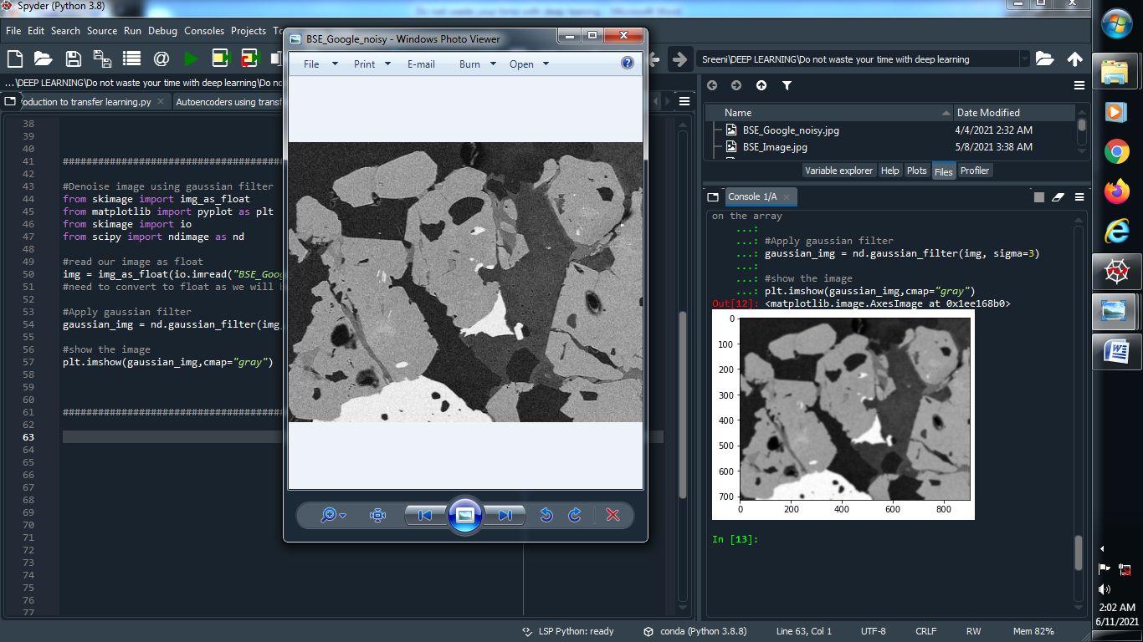

**(4) Denoise image using Anisotropic diffusion :**

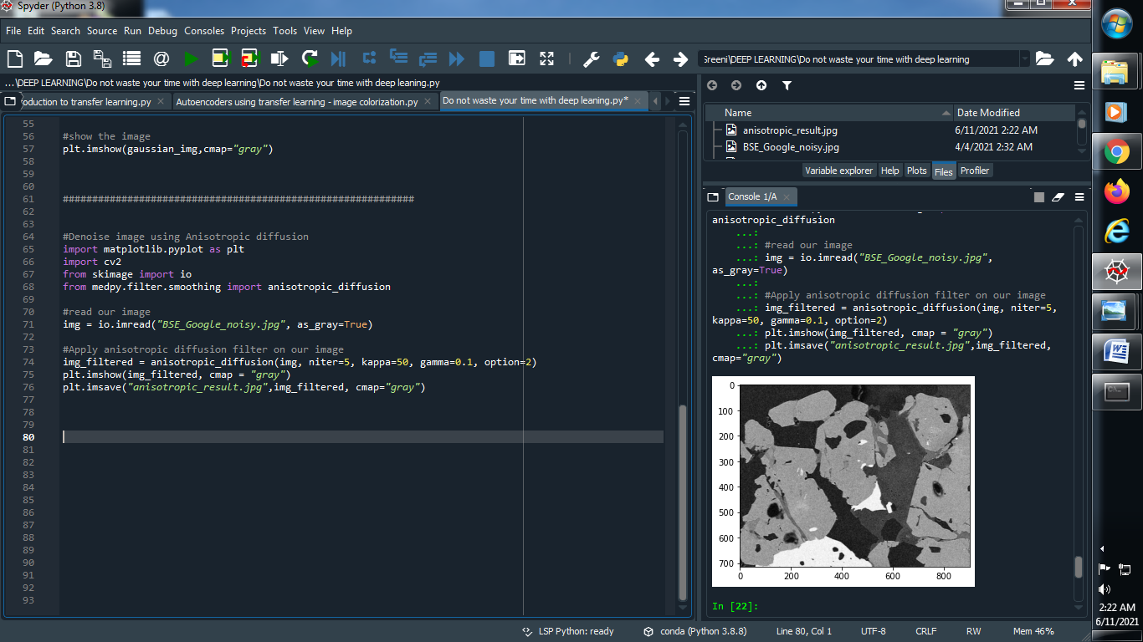

**Output :**

**Original image : Denoise image :**

